**Lab Exercise 3**

Step:

1. Go to Tomcat website to download Windows version 8.5
2. Extract and install it
3. Go to bin folder and double-click startup.bat

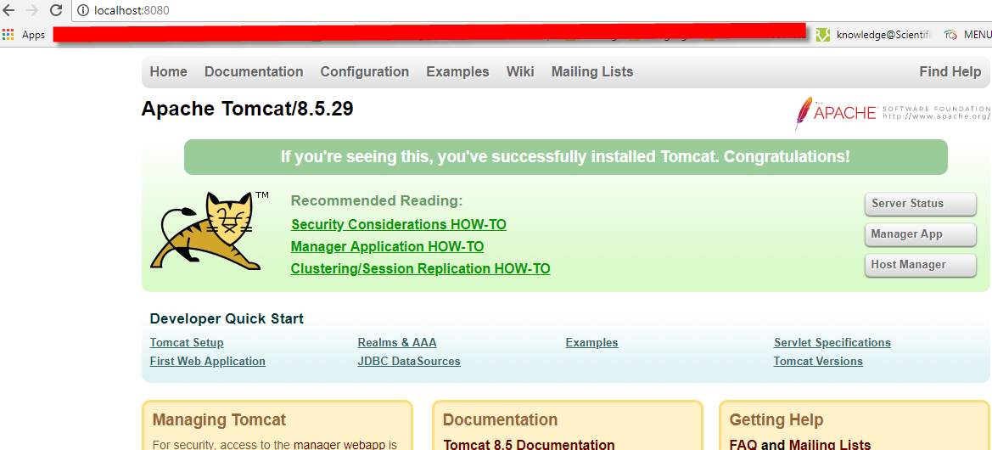

1. Double click Manager App, but it requires a user account
2. For accessing the console to see the webapps, go to conf folder to modify tomcat-users.xml

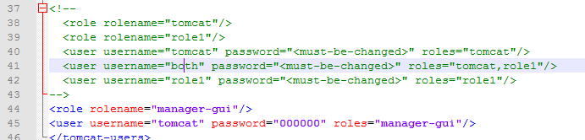

1. Then you can see below page:

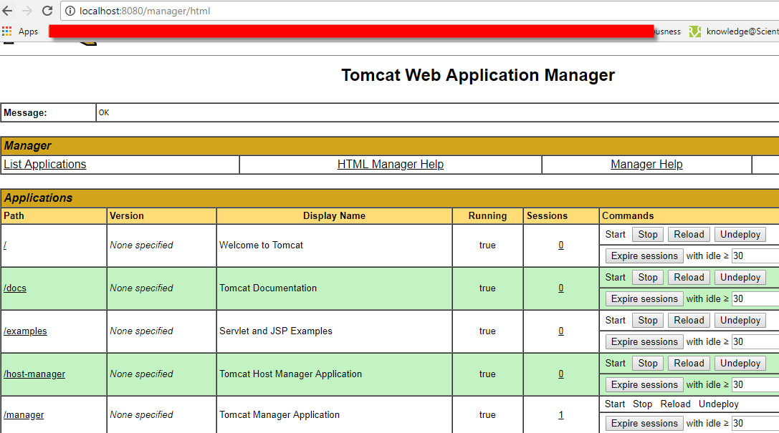

Problem: cannot execute it since the JAVE and JRE path are not correct. Solution: Go to bin and then modify setclasspath.bat as below red rectangle.

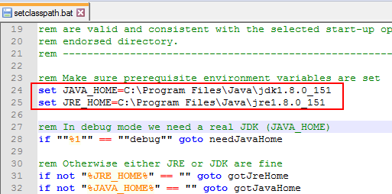

**Labe Exercise 4**

Steps:

1. Go to webapps folder and create Exercise4 folder
2. In Exercise4 folder, create WEB-INF which also create a folder named classes and a file called web.xml
3. In classes folder, create Exercise4.java with following code:

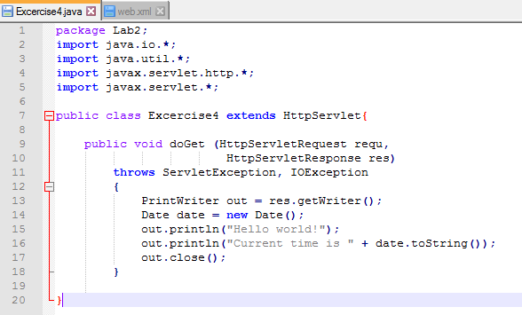

1. In web.xml, write servlet tag and servlet-mapping tag as below: (welcome-file-list and error-page are optional in this exercise)

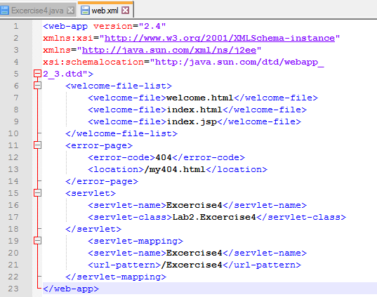

1. Compile Exercise4.java to be Exercise4.class (by running “javac -cp MyApache-tomcat-8.5.2x/lib/servlet-api.jar Exercise4.java”)
2. Open Chrome and enter url “localhost:8080/Exercise4/Excercise4”, and get the following result:

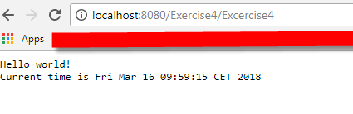

Exercise5

Steps:

1. Make a html file with three input boxes and one submit button:

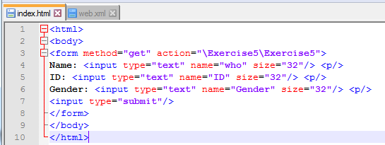

1. Create a java file in ..\apache-tomcat-8.5.29\webapps\Exercise5\WEB-INF\classes with below code:

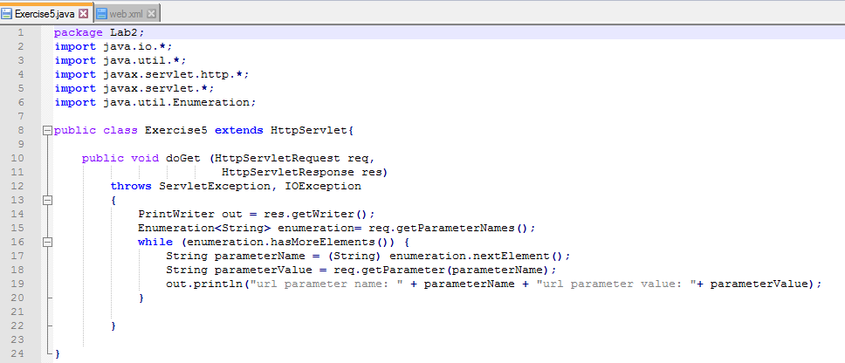

1. Create a xml file called web.xml in ..\apache-tomcat-8.5.29\webapps\Exercise5\WEB-INF with following code:

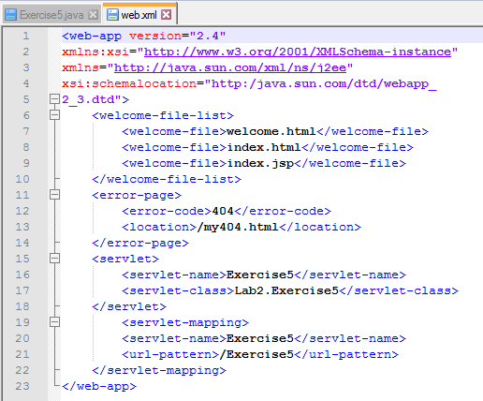

1. Compile Exercise5.java to be Exercise5.class (by running “javac -cp MyApache-tomcat-8.5.2x/lib/servlet-api.jar Exercise5.java”)
2. Open Chrome and run url “localhost:8080/Exercise5”, then fill out the three input boxes, and click submit button.
3. The below is the executed result:

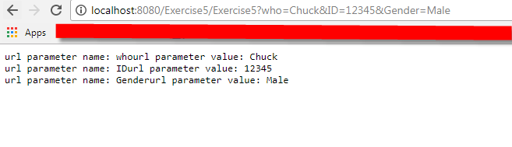

Problem: don’t know how to extract the get request. Solution: check the hint and google, and then found how to use Enumeration.hasMoreElements with while loop to one by one extract the parameter name and value.

**Exercise6**

Steps:

1. In Eclipse preference, go to Server > Runtime Environment > Add Apache Tomcat v8.0
2. New Dynamic Web Project
3. Create index.html in WebContent and then go to WebContent folder
4. Move to WEB-INF and create classes folder and web.xml as below:

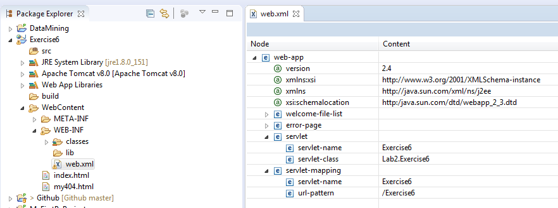

1. In classes folder, create Exercise6.java and compile it to be Exercise6.class

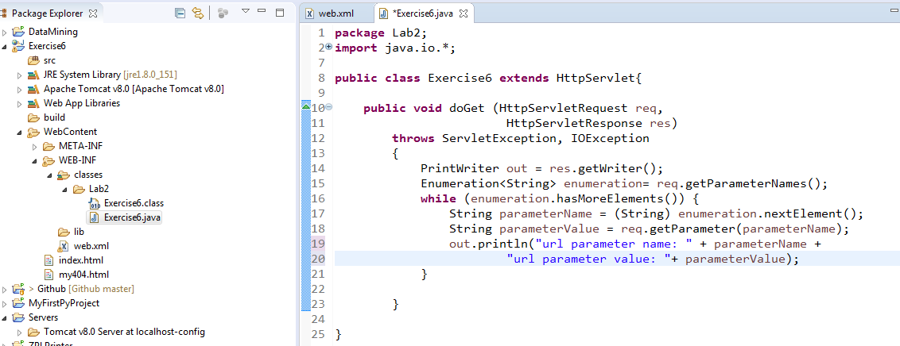

1. Run on Server

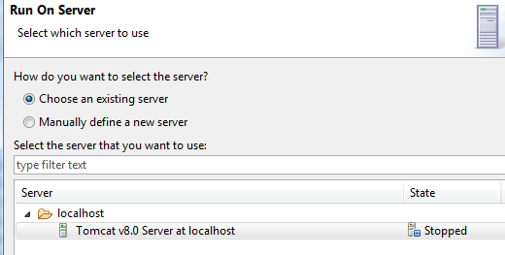

1. The page will be popped out as following: (the input boxes are filled after the page prompted)

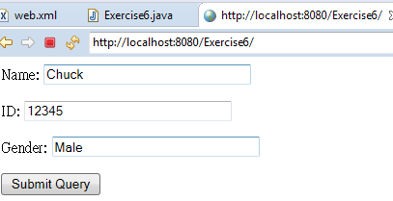

1. Submit and see the result below:

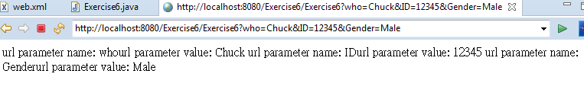

1. Export it to be WAR
2. Go to Tomcat > bin > run Startup.bat
3. On the home page, go to Manager App with the account you have set before (mine is account: tomcat; Password: 000000)
4. In WAR file to deploy, Choose File “Exercise6.war” and then deploy

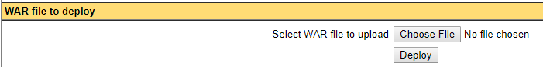

1. In Applications, /Exercise6 is running:

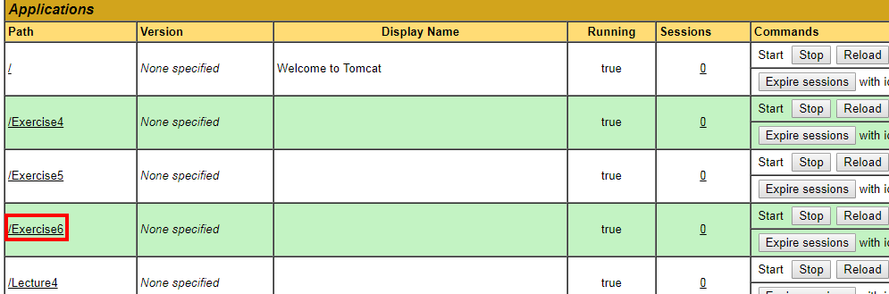

1. The result is like below:

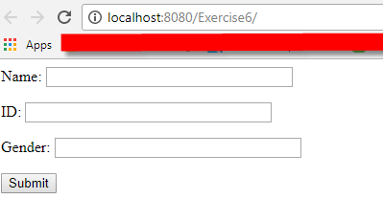

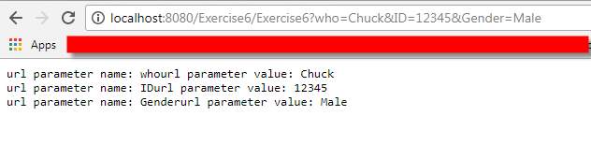

Problem1: Cannot find Dynamic Web Project. Solution1: (1.) Click "Help" > "Install new software" (2.)In "Work with", paste: <http://download.eclipse.org/releases/kepler> (3.) In "Web, XML, Java EE and OSGi Enterprise Development", check:

* + Eclipse Java EE Developer Tools
  + Eclipse Java Web Developer Tools
  + Eclipse Web Developer Tools
  + Eclipse XML Editors and Tools

(4.) Finally, click "Next" to install the new software and "Dynamic Web Project" will be available.

Problem2: Cannot select tomcat8.5.2 as run target. Solution: modify the version of my tomcat from 8.5.2 to 8.0, so Eclipse tomcat can be used. To modify it, the steps are the following:

